Escape Room Game (Console Based)

ABSTRACT
Abstract
The Escape Room Game is a console-based mini project developed using Python core concepts and Object-Oriented Programming (OOPS). The main objective of this project is to create an interactive text-based game where the player must solve puzzles and riddles to escape from different rooms.
In this game, the player progresses through a sequence of rooms, each containing a unique challenge such as logical puzzles, riddles, or simple problem solving tasks. The player must carefully analyse the given clues and provide correct inputs to unlock the doors and move to the next room. Incorrect answers require the player to retry until the puzzle is solved successfully. And the players have limited lifes.
This project emphasizes the use of OOPS principles such as classes, objects, encapsulation, and methods to design a modular and well-structured application. The console-based approach keeps the system simple, light weight, and beginner-friendly. It is suitable for beginners and helps improve logical thinking and programming skills

🔑 Key Features
- Console-based interactive gameplay
- Multiple escape rooms with unique levels
- User input validation
- Step-by-step room progression

- Motivational messages

- Modular and structured design using OOP’s
- Beginner-friendly and easy to understand

💻 Technologies Used
- Programming Language: Python
- Concepts :
  - Python Core
  - Object-Oriented Programming (OOPS)
  - Classes and Objects
  - Encapsulation
- Platform : Terminal / Console

Program
class Player:
def __init__(self,name):
self.player_name = name
self.lvl = 1
def show_details(self):
print("\n\nPlayer Name : ",self.player_name)
print("Player Level : ", self.lvl)
def level_add(self):
self.lvl += 1
print("--- Level add up ! ---")
class Puzzle:
def __init__(self):
self.life = 3
def lvl_1(self):
while self.life > 0:
print("\nStay calm, think smart 🎯")
print("\n-----LEVEL ONE : Number Puzzle-----")
print("\n--------------------------------------------------------------")
print("What is '5 + 3 = ?'")
try:
answer = int(input(" Enter Your Answer: "))
except ValueError:
print("\nPlease Enter Valid Input")
continue
if answer == 8:
print("\nCorrect Answer ")
print("\nLevel Up! Brain power ON 🔥")
return True
else:
print("\nWrong Answer ")
print("Legends don’t quit 💥, Try Again!!!")
self.life -= 1
print("Balance Life : ",self.life)
print("\nYou Don't Have Anymore Life")
print("\n\n\n😞 GAME OVER! Your lives are exhausted !!!")
return False
def lvl_2(self):
while self.life > 0:
print("\n-----LEVEL TWO : Riddle Puzzle-----")
print("\n Think fast time to prove your skills!")
print("--------------------------------------------------------------")
print("\nWhat has hands but cannot clap ?")
answer = str(input(" Enter Your Answer: ")).lower()
if answer == "clock":
print("\nCorrect Answer ")
print("\nYou’re doing great, keep going! 💪")
return True
else:
print("\nWrong Answer ")
print("Legends don’t quit 💥, Try Again!!!")
self.life -= 1
print("Balance Life : ",self.life)
print("\nYou Don't Have Anymore Life")
print("\n\n\n😞 GAME OVER! Your lives are exhausted !!!")
return False
def lvl_3(self):
while self.life > 0:
print("\n\n-----LEVEL THREE : Missing Number Puzzle-----")
print("\n--------------------------------------------------------------")
print("Find the next number in the series: 2, 4, 8, __, 32")
answer = str(input(" Enter Your Answer: "))
if answer == "16":
print("\nCorrect Answer ")
print("\nSharp mind wins the game!")
return True
else:
print("\nWrong Answer ")
print("\nLegends don’t quit 💥, Try Again!!!")
self.life -= 1
print("Balance Life : ",self.life)
print("\nYou Don't Have Anymore Life")
print("\n\n\n😞 GAME OVER! Your lives are exhausted !!!")
return False
def lvl_4(self):
while self.life > 0:
print("\n\n-----LEVEL FOUR : TRUE/FALSE Puzzle-----")
print("\n--------------------------------------------------------------")
print("Python is a case-sensitive programming language (True / False)")
answer = str(input(" Enter Your Answer: ")).lower()
if answer == "true":
print("\nCorrect Answer ")
return True
else:
print("\nWrong Answer ")
print("Legends don’t quit 💥, Try Again!!!")
self.life -= 1
print("Balance Life : ",self.life)
print("\nYou Don't Have Anymore Life")
print("\n\n\n😞 GAME OVER! Your lives are exhausted !!!")
return False
def lvl_5(self):
while self.life > 0:
print("\n\nOne step closer to escape 🚪")
print("\n-----LEVEL FIVE : (Odd one out) Puzzle-----")
print("\n--------------------------------------------------------------")
print("Find the odd one out: [ Apple, Banana, Carrot, Mango ]")
answer = str(input(" Enter Your Answer: ")).lower()
if answer == "carrot":
print("\nCorrect Answer ")
print("\n\n🎉 CONGRATULATIONS! You escaped the room successfully!")
print("\n\n***************************************************************************************")
print("\n************************************* GAME OVER ***************************************")
print("********************************* LEVELS COMPLETED ************************************")
print("\n***************************************************************************************")
return True
else:
print("\nWrong Answer ")
print("\nLegends don’t quit 💥, Try Again!!!")
self.life -= 1
print("Balance Life : ",self.life)
print("\nYou Don't Have Anymore Life")
print("\n\n\n😞 GAME OVER! Your lives are exhausted !!!")
return False
def main():
print(" !----- WELCOME TO ESCAPE ROOM GAME -----!")
name = input("Enter your name: ")
p = Player(name)
p.show_details()
p.level_add()
print("\n1.START")
print("\n2.EXIT")
choice = int(input("\nEnter your choice: "))
if choice == 1:
print("\nYOU are Going to Enter The Game !!!")
puz = Puzzle()
puz.lvl_1(),p.level_add()
puz.lvl_2(),p.level_add()
puz.lvl_3(),p.level_add()
puz.lvl_4(),p.level_add()
puz.lvl_5(),p.level_add()
elif choice == 2:
print("YOU end UP the Game")
else:
print("\n Enter valid choice")
main()

🎯 Goals of the Project
- To design a simple console-based game using Python
- To understand and apply OOPS concepts in a real-time project
- To improve logical thinking and problem-solving skills
- To provide a fun and interactive learning experience for beginners
Modules:
- Player Module
- Level Module
- Puzzle Module
- Controls Module

Module 1: Puzzle Module (puzzle.py)
Description:
This module contains all puzzle-related logic used in the Escape Room game.

Responsibilities:
- Define a common structure for all puzzles
- Display puzzle questions to the player
- Validate player answers
- Return puzzle result (correct or incorrect)
Puzzle Levels:
- Level 1 Number Puzzle
- Level 2 Riddle Puzzle
- Level 3 Missing Number Puzzle
- Level 4 True / False Puzzle
- Level 5 Odd One Out Puzzle

Module 2: Player Module (player.py)
Description:
This module manages all player-related data and actions.

Responsibilities:
- Store player information (name, attempts)
- Reduce attempts after wrong answers
- Provide player status (active or game over)

Concepts:
- Get user name as input
- Show player level
- Encapsulation (private data members with getters and setters)

Module 3: Main Module (ERG_Module.py)

Description:
This is the main controller module of the project.

Responsibilities:
    - Displays Welcome Screen
    - Start and manage the game flow
    - Create player and room objects
    - Call puzzle one
    - Check win or lose conditions • Display final game result

Concepts Used:
    - Object interaction
    - Control flow management

Module Execution Order

puzzle.py – Puzzle logic player.py – Player data handling room.py – Room management game.py – Overall game control

Flow Chart Diagram
- Start
- Enter Player Name
  - Show Player Details
- Choose (1.Start / 2.Exit)
  - If Start Go to Level 1
- Solve Puzzle?
  - TRUE → Next Level
  - FALSE → Life - 1
  - If Life = 0
  - Game End
- After Level 5 Completed
- Show Final Result
- End

Output Screenshot: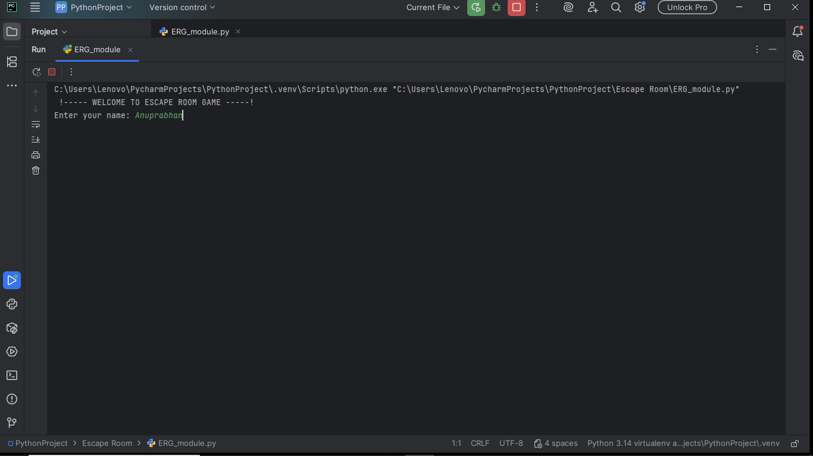

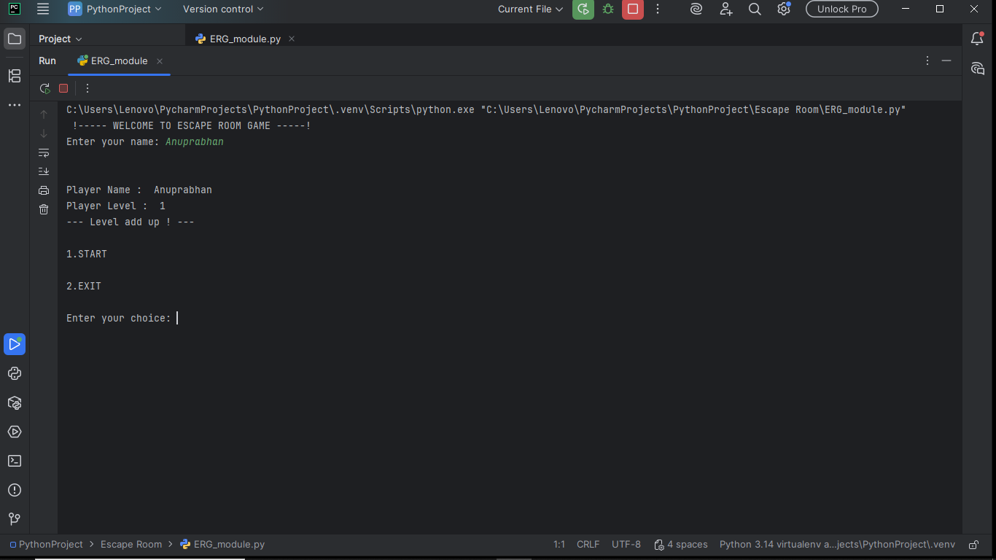

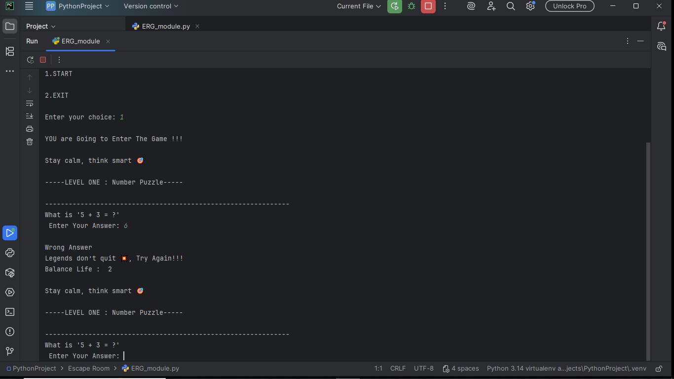

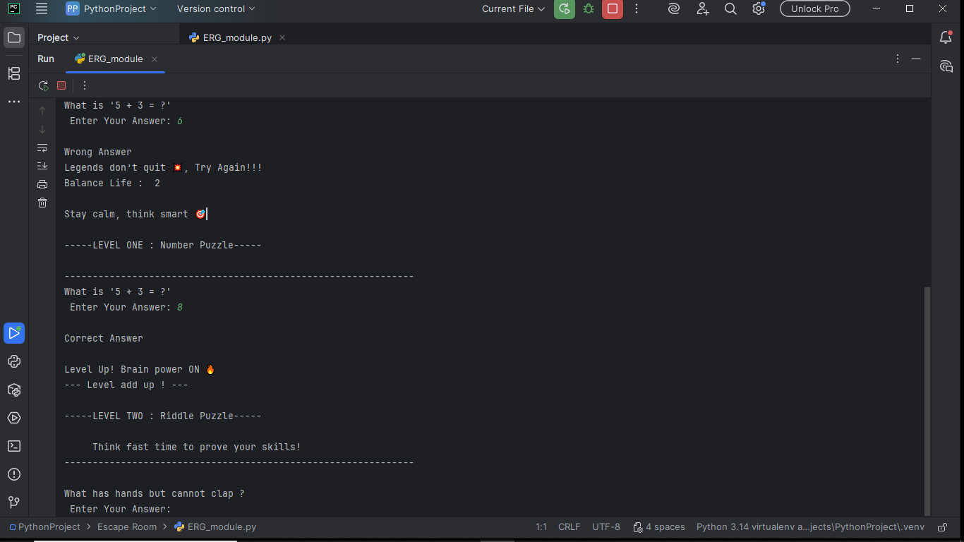

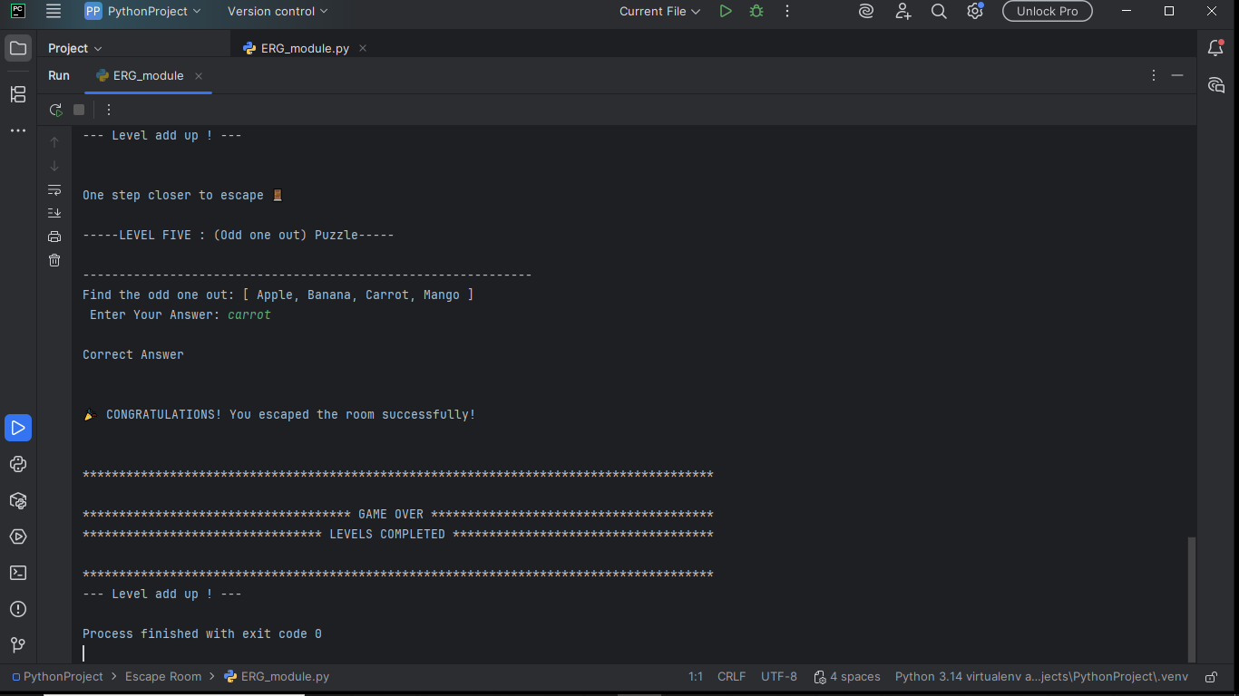

Future Enhancements
- Add timer-based challenges
- Add multiple rooms / stages
- Add scoreboard system
- Convert to GUI using Tkinter or Pygame

Conclusion

This mini project successfully demonstrates the implementation of a simple Escape Room Puzzle Game using Python. It applies important programming concepts such as loops, decision making, methods, and object-oriented programming. The project is engaging, educational, and suitable for beginner-level academic submissions

